Project Design Phase-II
Technology Stack (Architecture & Stack)

Date | 29 June 2026
Team ID
Project Name | Smart Agricultural Production Optimization Engine
Maximum Marks | 4 Marks

Technical Architecture:
The Deliverable shall include the architectural diagram as below and the information as per the table1 & table 2
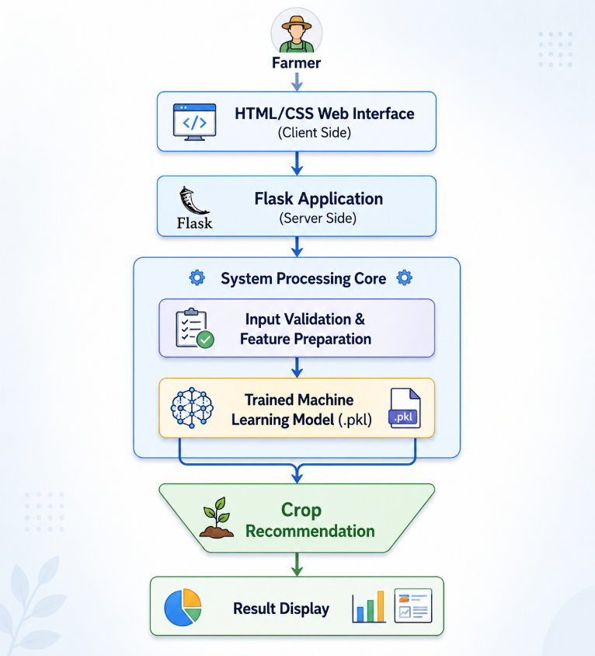
Table-1 : Components & Technologies:
Component | Description | Technology
User Interface | Farmer Web Application | HTML5, CSS3
Backend | Business Logic & Request Handling | Flask (Python)
Machine Learning | Crop Recommendation | Scikit-learn
Data Processing | Data Preparation & Analysis | Pandas, NumPy
Model Loading | Load Trained Prediction Model | Joblib
Development Environment | Model Training & Testing | Jupyter Notebook
Deployment | Local Web Application | Flask Development Server

Table-2: Application Characteristics:
Characteristic | Description | Technology
Open Source Frameworks | Backend & Web Application | Flask, Scikit-learn
User Interface | Responsive Web Interface | HTML5, CSS3
Data Processing | Data Preparation & Analysis | Pandas, NumPy
Machine Learning | Crop Prediction | Scikit-learn, Joblib
Performance | Fast Prediction Response | Flask, Scikit-learn

Table-3: Technology Stack:
Category | Technology
Programming Language | Python
Backend Framework | Flask
Machine Learning | Scikit-learn
Data Processing | Pandas
Numerical Computing | NumPy
Model Storage | Joblib
Frontend | HTML, CSS
IDE | VS Code / PyCharm
Version Control | Git

